Revisit

1. Week wise approach
2. Types of Memory, Operating System, Unix commands (Cygwin & Git bash)
3. Github & Git (Command) , AWS – EC2 (IaaS, PaaS, SaaS) Public & Private Cloud
4. Created an Account in Github & AWS (Free-tier), Created a repository
5. Cloning & Forking, Created EC2 in AWS
6. AMI, IAM, EC2, ECS, EKS, RDS

JAVA – Programming Lang

1. Java is a Platform Independent, Architecture Neutral, Multi-Threaded, Highly Secured, Object Oriented, General purpose programming Lang
2. Java is High Level Language
3. Editions – Java Standard Edition, Java Enterprise Edition, Java Micro/Mobile Edition
4. JDK (Java Development Kit), JRE (Java Runtime Environment), JVM – Java Virtual Machine
5. JVM – Virtual Computer created completely by software only
6. JAVA is platform independent language but jdk, jre & jvm are all platform dependent.

JDK8 can be downloaded from -- <https://www.oracle.com/java/technologies/downloads/#java8-windows>

Jdk is needed to develop Java based projects/applications

JRE is needed to run any java based projects/applications

JAVA is highly recommended language for Banking Applications

Java is used in Big-Data, Pega, Android (Java + Linux Kernel)

Stand-alone application – Core Java Applications (Desktop based applications) – Install and use

Web based Applications – These applications will run inside browser

Enterprise Applications – CLI, Web Interface, Mobile Interface (Facebook/WhatsApp)

It’s available for mobile (iOS, Android, other mobile based OS), desktop app (download & install), browser based application (web.whatsapp.com, facebook.com)

Why JAVA

1. Platform Independent
2. Highly Secured
3. Highly scalable, portable
4. WORA – Write Once and Run Anywhere

Java source code will have a extension called .java (Source Code)

The compiled java source code will have a extension called .class (Byte Code/ Intermediate Code)

Java Source code (.java) --- Java Compiler -🡪 Byte Code (Intermediate Code - .class) –executed in--🡪 JVM (JIT – Just InTime Interpreter)

JAVA is both compiled as well as interpreted language.

Compilation – converts entire code from source to target

Interpretation – Converting the source to target line by line

Java is a Object Oriented Programming Lang, But, It’s not a pure object oriented lang bcos of primitives (Non-Objects)

Data Types – While creating/declaring a variable need to inform the jvm about the type of data that the variable can store.

DataTypes 1)Primitive Data types 2) Derived Data Types

Primitive Data Types (8 primitive data types)

1. boolean (1 bit – true or false value)
2. byte (1 Byte – 8 bits – Storing number)
3. short (2 bytes – 16 bits -Storing number)
4. char (2 bytes – 16 bits – Storing character/ alphabets)
5. int (4 bytes – 32 bits – storing numbers)
6. long (8 bytes - 64 bits numbers – big range)
7. float (4 bytes – 32 bits - floating point numbers)
8. double (8 bytes – 64 bits - to store double precision numbers)

Derived Data types

1. class
2. enum (array with fixed values)
3. arrays

Learn alphabets – JAVA – A-Z, a-z, 0-9, +,-,*,/,%,=,==, +=,-=,*=,/=,%=, ++, --, (), [], {}, >, :, ;, ., ,

Words - JAVA – keywords are reserved words (Which will have pre-defined meaning)

Class, break, char, int, float, double, long, short, if, for, while, do, continue, package, extends, implements, private, public, final, static, abstract, finally, protected, try, catch, throw, throws

We can’t use keyword while creating a variable.

Variable – In order to store data/values we create variables.

Naming Conventions

JAVA is a case-sensitive language

Hello is different from hello.

Syntax(Grammer) to create a variable

<data_type> <name_of_variable> [= <value>]; //the one given in square bracket is optional section

Data_type = boolean, byte, char, short, int, long, float, double

Operators [Arithmetic Operators +,-,*, /, %, ++, --]

Comparison Operators [<,>,==,!=]

Conditional Operator [&&, ||, !]

Bit-wise operator [ &, |, !, ~, ^, <<, >>]

Javac – will call the java compiler (When calling java compiler, we need to pass java source code with .java extension)

Java – will call the jvm ( while calling the jvm, we need to pass the bytecode without .class extension)

To write a Java program , we need any text editor (notepad, notepad++, wordpad, terminal (mac), vi editor in linux)

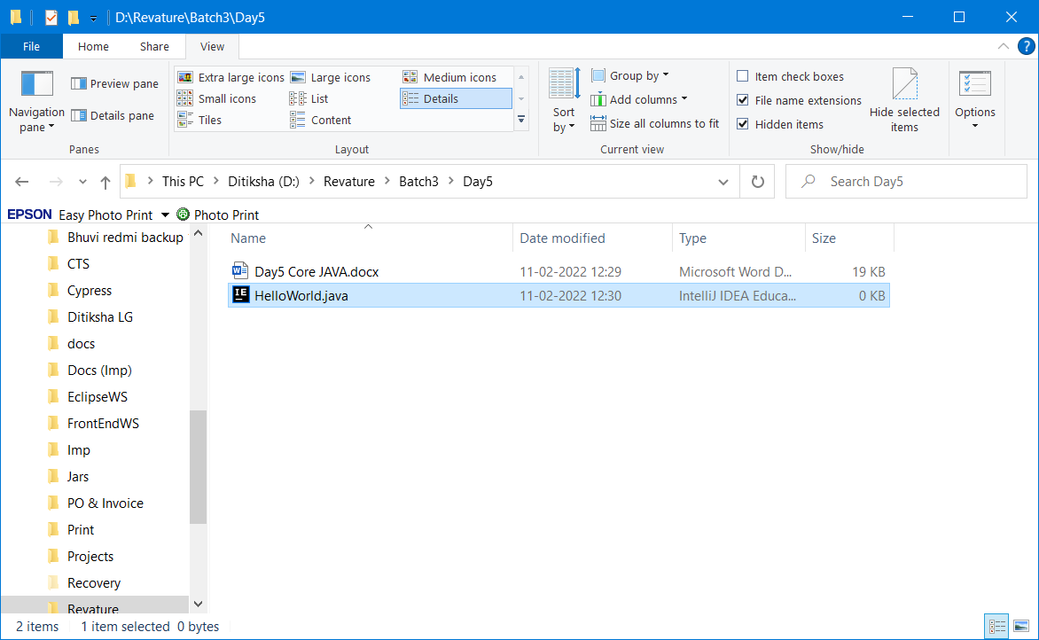



In Java, the name of the public class and the name of the file, both should be same.

Class naming Convention – Class name should start with a Capital letter. If it’s more than one word, beginning of each word first character should be capitalized. – camel casing

public class HelloWorld {

public static void main(String[] args) {

System.out.println("Welcome to JAVA World");

}

}

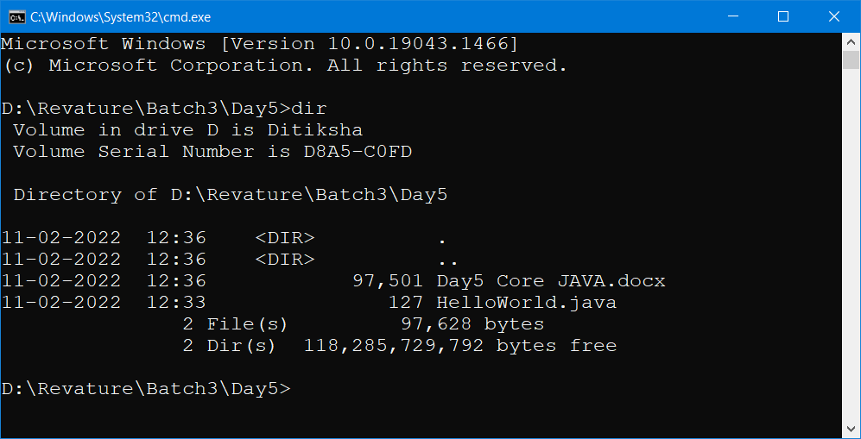

Javac HelloWorld.java (compiling the java source code and converting it to byte code)

type HelloWorld.java

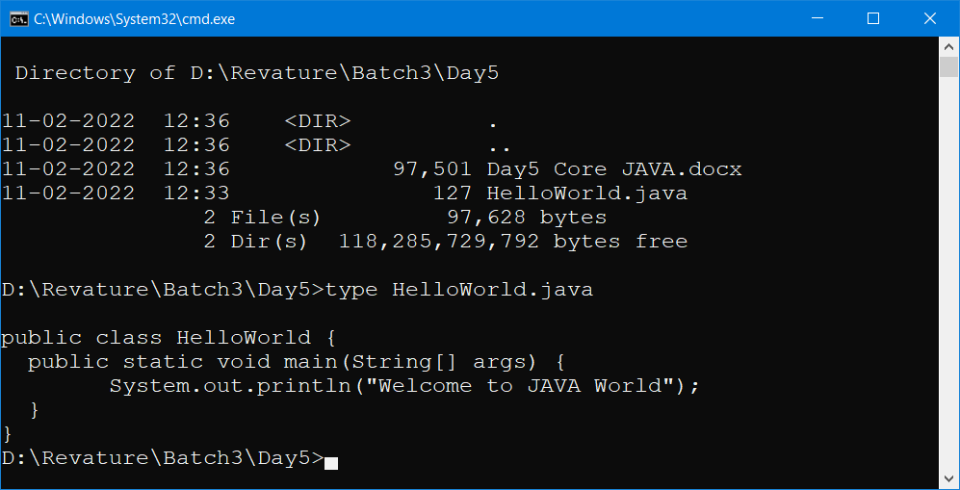

javac HelloWorld.java

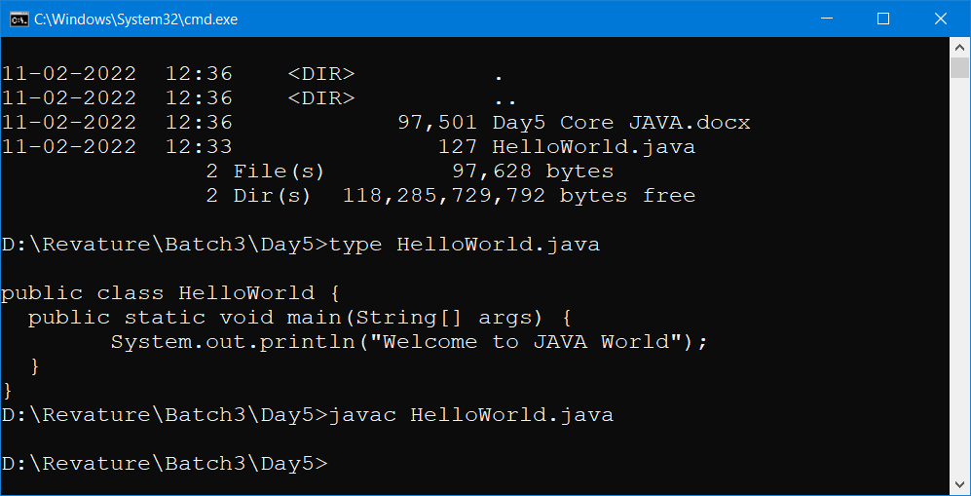

If no error in the source code, then we will get the command prompt back as shown above.

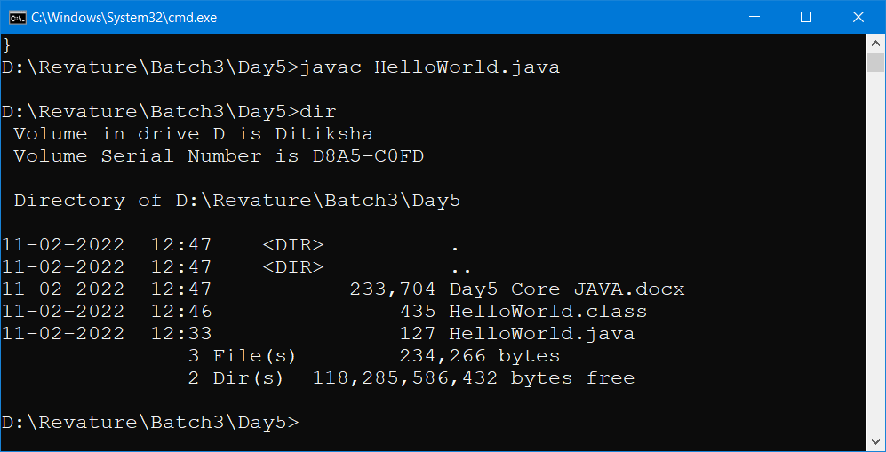

Java HelloWorld

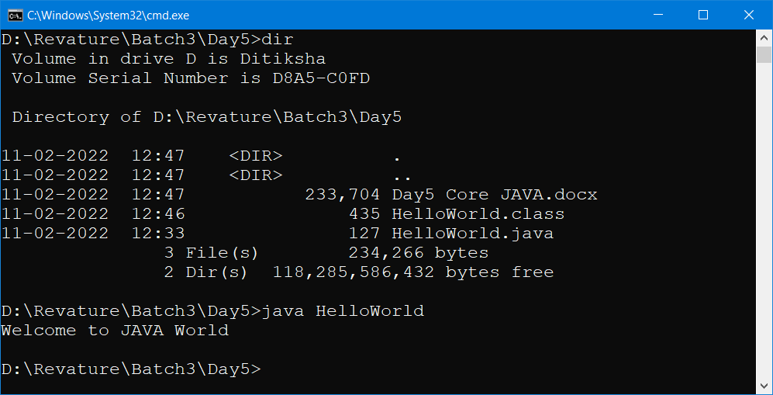

Method & Method Arguments

Method – It’s a function written inside a Class.

Method declaration / method signature --- public void add( int a,int b)

Method Signature and method declaration both are same.

The data that is passed to methods is called arguments.